**Workshop on**

**A paradigm shift in research: essentials for International Referred Journals**

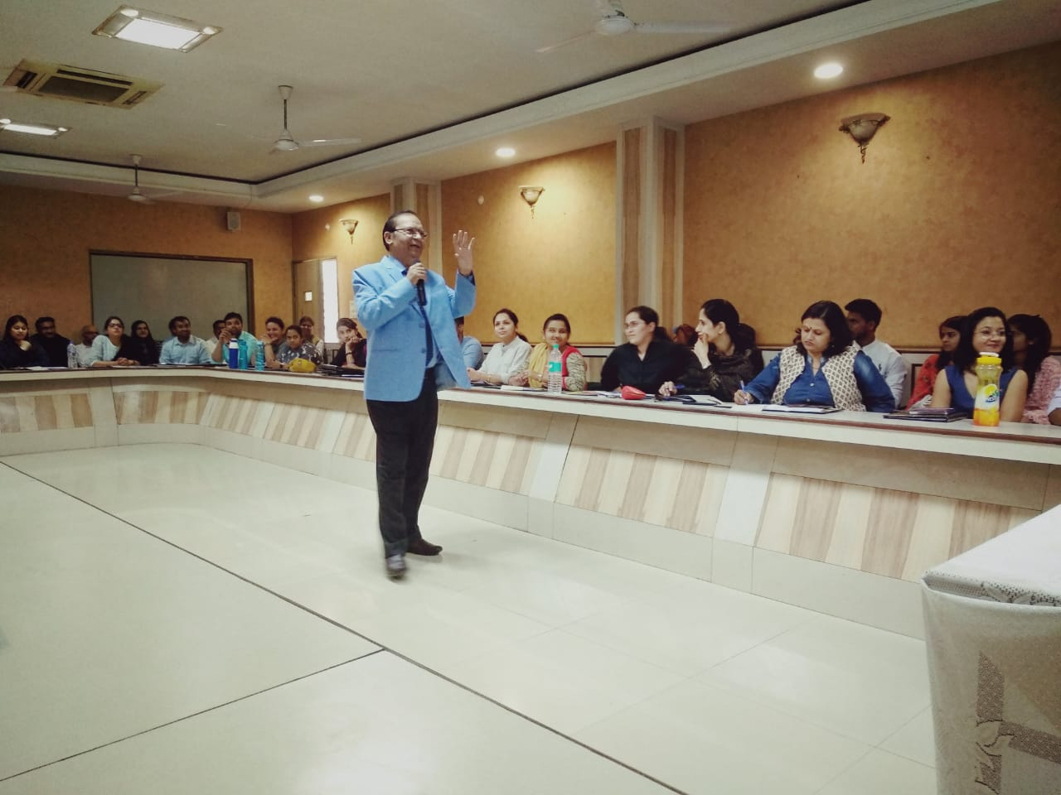Dr. J K Sachdeva during his session highlighted the importance of research publication. He stressed on the idea that what are international journals and what do they look forward to interms of research publication.

